
2-3 year olds
Long Term Curriculum Overview 2024-2025

2-3 year olds | Autumn 1  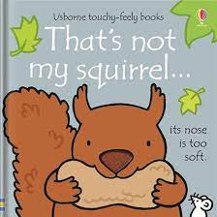  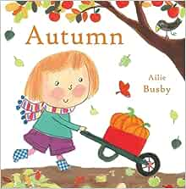 | Autumn 2  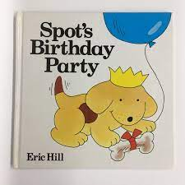   | 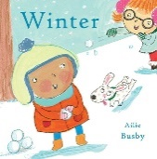  Spring 1  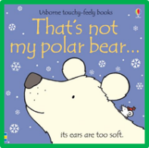 | Spring 2  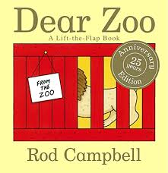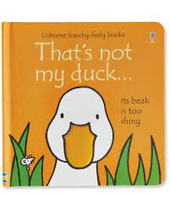 | Summer 1  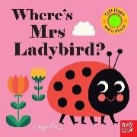  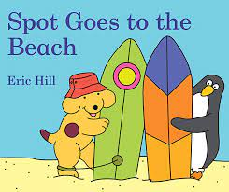 | Summer 2  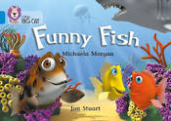  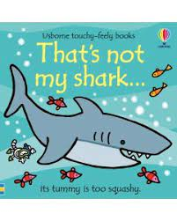
Rhymes | Head, shoulders knees and toes.  Twinkle Twinkle little star | Happy birthday  Jingle bells  Twinkle twinkle Christmas star. | I’m a little snowman  3 little snowmen | 3 little ducks  3 little monkeys | Incy Wincy Spider  Beehive song | 1,2,3,4,5 once I caught a fish alive  I had a little turtle
Personal, Social and Emotional  Development | To build key person relationships, supporting children when separating from a  Parent/Carer through the transitional period.  With the support of a key person show an interest in play.  Notice others around them.  Build interactions through the interests of the child.  To react to stimulus to help calm emotions and feelings for example: looking at family photographs together. |  | To begin to find their own unique way of managing transitions.  Begin to show confidence within their play.  Play alongside their peers and developing friendships.  With the support of an adult wait and take a turn for example rolling a ball or a car.  Begin to show an awareness of themselves. Using various props and resources. |  | To have developed a sense of assurance for example developing relationships with other adults and peers.  Show independence within their play and making choices.  To have established friendships with peers.  To begin to demonstrate taking a turn independently.  Explore emotions and feelings through stories and their play.
Communication and Language | To begin to join in with some songs and Nursery  Rhymes (even just with actions)  To being to change attention to follow a prop or prompt.  Listen to short stories in a small group.  Use some single words to express their wants, needs and feelings.  Recognise familiar objects to develop their vocabulary. |  | Recognise familiar environmental sounds and say what they can hear.  Listen to some longer stories and join in with some key words and phrases in familiar stories.  Build on their repertoire of Nursery Rhymes and begin to sing them unprompted.  Begin to put a few words together and speak in simple sentences to express their wants, needs and feelings.  Use the speech sounds p,b,m,w |  | To be able to shift to a different task if attention fully obtained.  Listen and follow one step instructions, begin to follow 2 step instructions.  Listen and join in during circle times, taking a more active role in participating.  Know and sing a wide variety of Nursery Rhymes and songs.

 | Understand frequently used words, such as, ‘all gone’, ‘no’, ‘bye bye’. |  | Role play familiar scenarios, communicating with one another, for example, going to the shops or the Doctors.  Express themselves using a wide range of vocabulary and speak in longer sentences.
Physical  Development | Feeling secure and comfortable during nappy time.  At snack time sitting together with peers.  Sitting and walking independently.  Begin to sit on a small bike and know how it is used.  Showing an interest in exploring materials and tools. | Showing an interest in Potty training.  Sitting together for snack times and trying different tastes and textures.  To gain control over their bodies through both indoor and outdoor play.  Developing fine manipulative skills through using different objects and tools. | To be independent with their self-help skills such as washing their own hands, using the toilet and attempting to fasten their own coat.  Following snack time routines, making choices independently.  To use large equipment, ride bikes and scooters with support.  To be able to hold tools and objects using a palmer grasp comfortably.
Literacy- Reading | To explore looking at books independently. Explore sensory books and learn new vocabulary related to their senses.  Enjoy looking at class made books related to families.  To look at some non-fiction books related to Topics in small groups e.g. Autumn, Christmas etc.  To use a basic picture book and find information following a prompt. E.g. Where is the dog? | To choose books that interest them  independently and begin to understand how to handle them carefully, turning the pages independently.  To obtain information from a more detailed image in a book following a prompt. E.g. What is the duck doing?  Recognise their name alongside their photograph. | Have a selection of favourite stories.  To understand that stories have a beginning and the end and join in saying ‘The end’.  To join in with key phrases when reading familiar books with adults.  To talk in simple sentences and phrases about books the enjoy, using the images to help them.  To listen to audio stories without images.  Recognise familiar logos related to their interests.

Literacy Writing | To join in with short dough gym sessions to develop fine motor control  To make marks on table tops to support core strength.  Show an interest in mark marking- fingers, large apparatus, tools.  Hold a tool with a fist palmer grip. | Distinguishes between the different marks they make.  Use tweezers to pick up a small object.  To develop hand-eye co-ordination through scooping/pouring and filling activities. | Imitate during simple shapes such as circles and lines.  Make marks on a picture to stand for their name.  Enjoy drawing freely using a range of tools.  Notice some print such as familiar logo.  Children begin to develop tripod grip.  Use lacing cards to develop fine motor skills.
Maths | To combine objects such as stacking blocks and cups.  Put objects inside others and take them out again.  Begin to take part in finger rhymes with numbers.  To explore and use shape sorters and puzzles. | To begin to compare sizes, bigger, little and smaller.  To use number language in their play, beginning to sequence numbers orally 0-5.  To complete an inset puzzle and to demonstrate matching and sorting skills within their play.  To notice and comment on patterns including stripes and spots etc. | To begin to use the language of weight in everyday contexts and through stories and rhymes.  To explore space within the indoor and outdoor environment using their bodies to climb and travel through, over and under equipment to gain spatial awareness.  To use objects to make simple arrangements, using associated language ‘the same’.  Begin to count objects and actions in everyday contexts and counting up to 3 fingers.  Begin to notice numerals in the environment and make comments on what they see e.g. numerals on doors, buses, clocks etc

Understanding the World  Investigation &  Exploration  People, culture and communities  Time | Play and explore in their natural environment displaying high levels of engagement. Children to begin to respond by simple comments and nonverbal gestures and movements.  Begin to explore seasonal change e.g. the leaves are falling off the tree.  Exploring senses –and purpose of body parts  Naming body parts  Exploring light and colours through sensory play.  Exploring sound linking to bonfire night.  Play with a variety of wheeled toys, exploring pushing and pulling. | Continue to learn new vocabulary linking to seasonal change and notice the changes in the seasons.  Observing changes of state through ice/water and using their senses to explore.  Explore the natural world, focusing on digging and planting seeds.  Observe and notice flowers and plants growing using their senses. | Use descriptive terms, such as ‘hot’ and ‘cold’.  Create simple dens with adult support and begin to understand shade and keeping cool.  Use senses to explore sand/pebbles/water/bubbles.
 | Recognise their family and key people during key person time. Children to name their family by using a family photograph.  Be aware of some special celebrations (Diwali, Christmas, Birthdays)  Settling in to their new environment and understanding where things are located in the classroom. | Begin to imitate their own family and cultures through pretend play.  Be aware of other celebrations – Easter, Eid.  Begin to understand that there are different environments, for example, understanding that penguins live where it is cold. | Bring in photos from family days out to share during Key Person time.  Begin to have their own friends.  Recognising familiar places and logos through looking at photos (local shops, places of interest).  Talk about places they might go on a sunny day, for example, the beach. Imitate these experiences in the role play.
 | Learning about the basic routines of the day using a visual timetable. (Carpet time, tidy time, lunch time, home time etc.) | Begin to understand the sequence of dressing in warm clothes for outside (putting on outdoor suit, then wellies, then hat, gloves etc.) | Understand the routine of the day with less prompts.
Expressive Arts and Design | Explore different materials using all their senses.  Begin to show an interest in early mark making.  Explore sounds using musical instruments and sound makers.  Use our voices to make sounds.  Starting to develop imaginative play by exploring resources within the provision. | Manipulate and play with different materials, exploring textures.  Make early marks using various tools and equipment.  Beginning to experience tone, pitch and volume.  Join in singing songs and rhymes copying actions.  Beginning to use resources imaginatively, using resources in different ways. For example: using a block as a phone. | Use their imagination to begin to combine materials to make simple models, using tools to achieve what they have set out to do.  Intentionally making marks in different styles.  Expressing their ideas when mark making and sometimes giving meaning to them.  Explore different rhythms, beat and using their bodies appropriately.  Developing imaginative play from their own learning experiences, stories and rhymes.

